Content Management Systems (CMS)
LP10 PAT2 Scoring Guide
CMS Themes and Best Practices Platform 2

Assessment Instructions:
You will conduct research into the following topics:
- Online Resources
- Online Communities
- Support Options
- Best Practices
You will then use the platform of your choice to develop a website that you can apply what you learned about best practices and place the information on from your research.
The website should contain the information required per criteria on the scoring guide.
You will also provide your compare and contrast criteria on the website.
You will organize the information so that the pages have a logical flow and navigation.
You will have one page on the site for project documentation. You will link your Scoring Guide documentation on that page.
For the website documentation, you will need to show screen captures of:
- Before Modification
- After Modification
You will place them directly on the scoring guide with the criteria they correspond to.
You will submit the URL to open the home page of your final project website as your assessment.
Project Criteria Rating Scale

Fully met criteria, exceeded criteria  5.0 pts | Met Criteria at a basic level  4.0 pts | Criteria present with some errors needing revision  2.0 pts | Criteria not met  0.0 pts

Core Ability Rating Scale
Fully met criteria, exceeded criteria  2.0 pts | Partially Met  1.0 pts | Not Met  0.0 pts

Criteria | Pts
Explore best practices with Content Management System.
ONLINE RESOURCES
At least 5 CMS online resources for the second CMS studied are identified. | 5.0 pts
ONLINE COMMUNITIES
At least 2 CMS online communities for the second CMS studied are identified. | 5.0 pts
Benefits of CMS online communities are identified. | 5.0 pts
SUPPORT OPTIONS
At least 3 CMS support options for the second CMS are identified with costs if applicable. | 5.0 pts
BEST PRACTICES
At least 5 general best practices are identified for the second CMS studied. | 5.0 pts
At least 2 security best practices are identified for the second CMS studied. | 5.0 pts
CMS Comparison
You compare and contrast your second CMS platform with the first CMS platform. | 5.0 pts
WEBSITE
Website's design elements such as navigation, footer information, typography, body text, headings, graphics, links and color are balanced, practical, and aesthetic in order to create unity and consistency resulting in a harmonious visual appearance. | 5.0 pts
You modify header art of the installed theme or template.  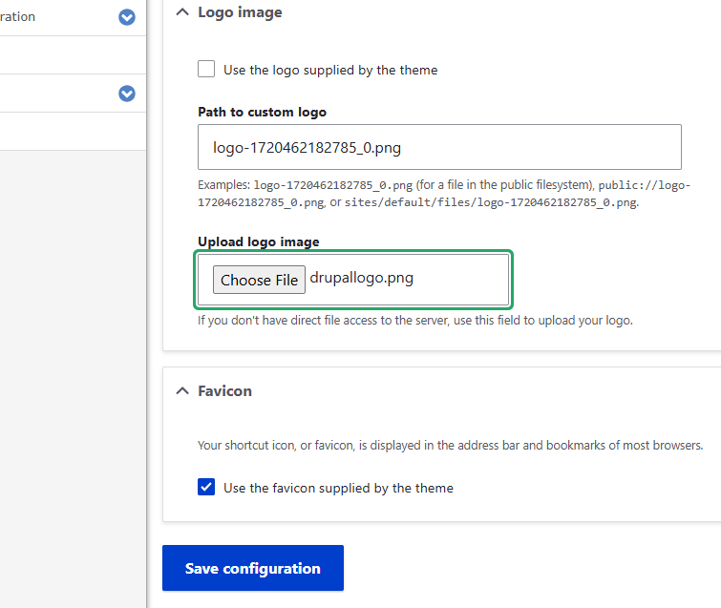  Added a new logo. | 5.0 pts
You configure installed theme or template options.  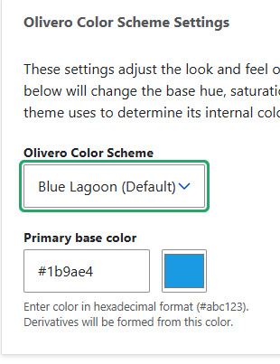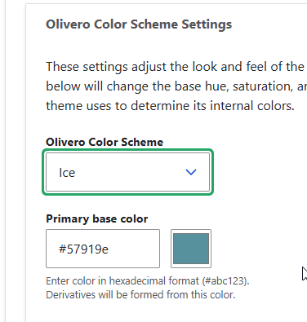  Changed the color to Ice but liked Blue Lagoon better. | 5.0 pts
Header is modified.  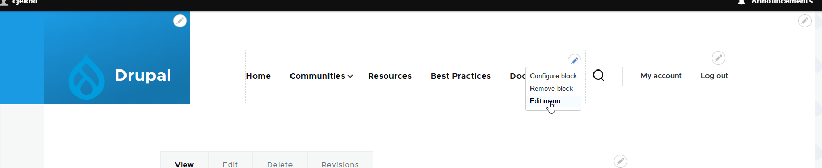  Edited the menu, colors, and logo at different points. | 5.0 pts
Custom color scheme is used.  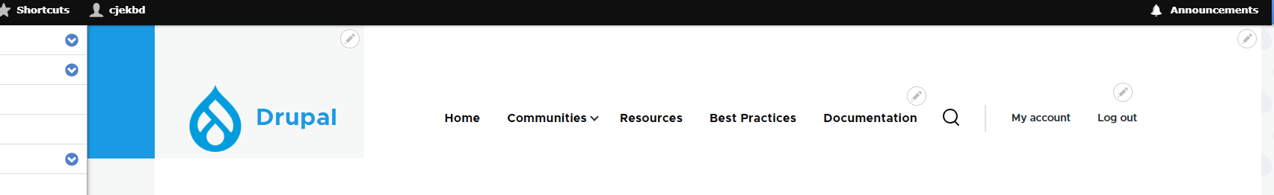  Tried a gray background – liked it better, I think the logo pops this way. | 5.0 pts
Images are modified and/or added.  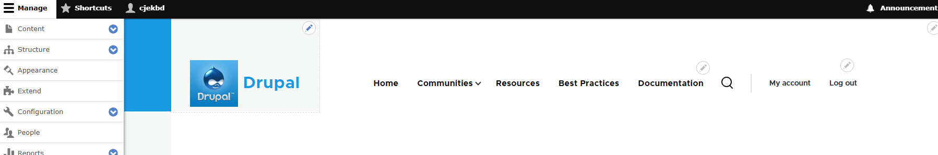  Tried this logo but I liked the other one better. | 5.0 pts
Content is modified and/or added.  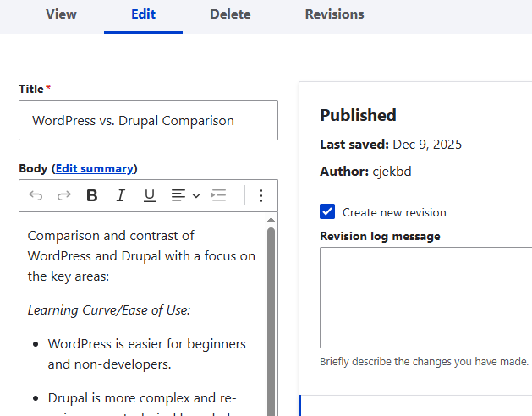 | 5.0 pts
Content structure is created using semantic content structures.  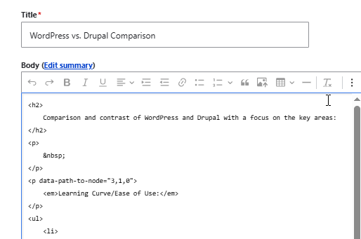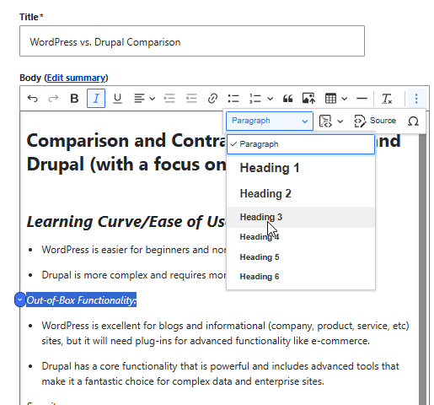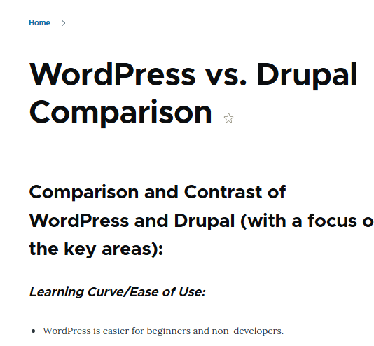  While messing around with the html, I also noticed that there was a dropdown which makes it super easy to change. | 5.0 pts
Copyright information is modified and/or added.  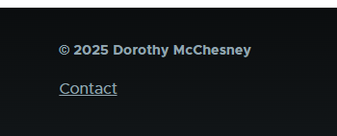  Added to the footer. | 5.0 pts
At least one layout aspect is modified and/or added.  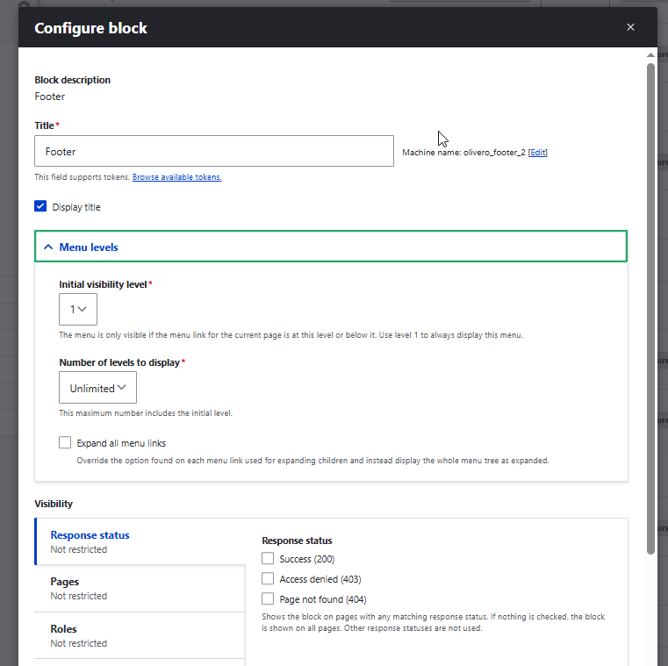  I used this process to add the copyright to the footer. | 5.0 pts
Access via the public URL is 100% functional.  URL: https://cms2.dotmcchesney.com/ | 5.0 pts
Core Ability Criteria
ACT RESPONSIBLY: Meet Deadlines  You meet deadlines | 2.0 pts
COMMUNICATE CLEARLY: Summarize in a Brief and Concise Manner  You summarize in a brief and concise manner  Reflection Statement: Include a reflection about your skills when you started this topic, what you gained and what you still have questions about. | 2.0 pts
COMMUNICATE CLEARLY: Demonstrate Mastery  You demonstrate mastery of grammar, spelling, punctuation, capitalization, word usage, and sentence structure | 2.0 pts
WORK PRODUCTIVELY: Use Resources Efficiently  You use resources efficiently  Cite Resources: Cite any resources that you used to help you gain the skills that you demonstrated in this assessment.  Resource Citations: | 2.0 pts
Total:

